LAB ASSIGNMENT 4.1:

## TASK 1:

Write a python program to generate a function that validates an indian mobile number.

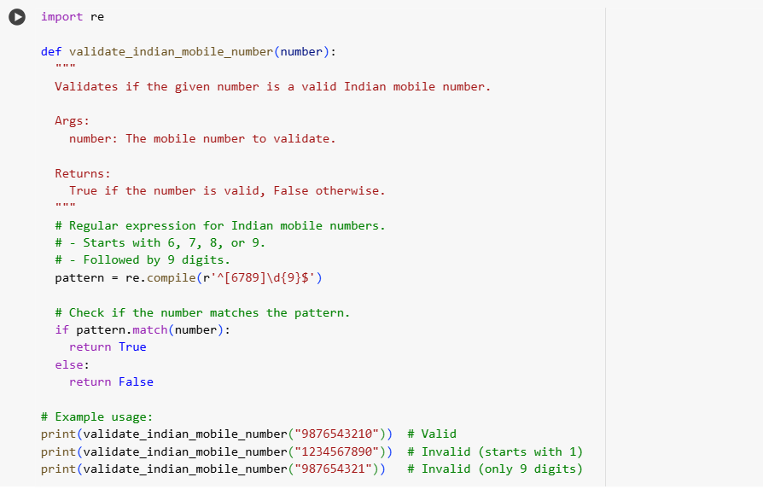

OUTPUT:



EXPLANATION:

TASK 2:

Write a python program that calculates factorial of a number using functions

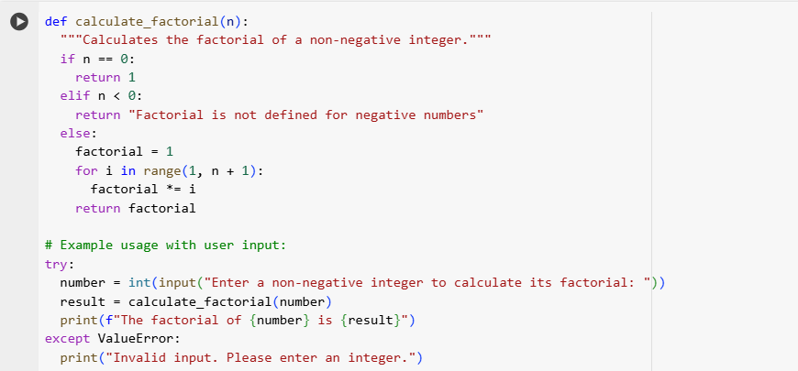

OUTPUT:



EXPLANATION:

TASK 3:

{John Doe , Computer Science,8.5},{ nithya,ece,9.3},{rahithya,mechanical,9.3} with this examples write a python program using functions to extract and return Full Name Branch SGP

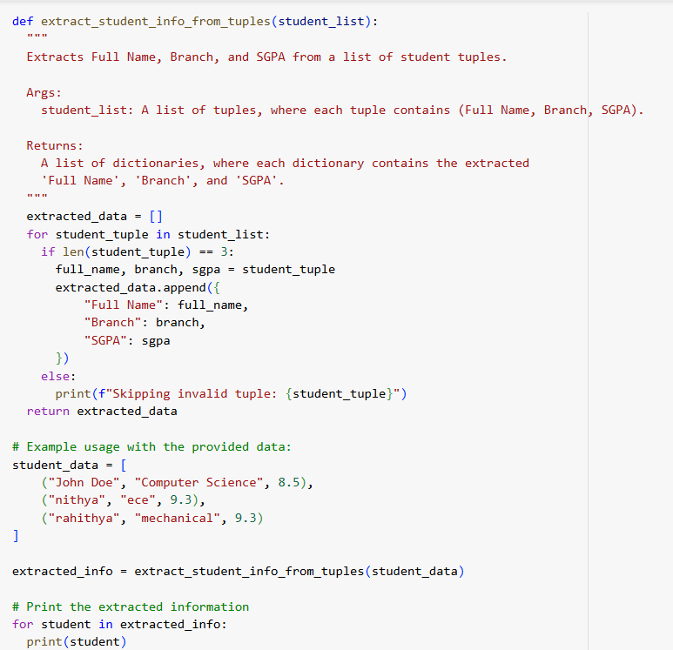

OUTPUT:

EXPLANATION:

TASK 4:

write a python program that reads a csv file,return the no.of rows,count the no.of empty rows,o Count the number of words across the file

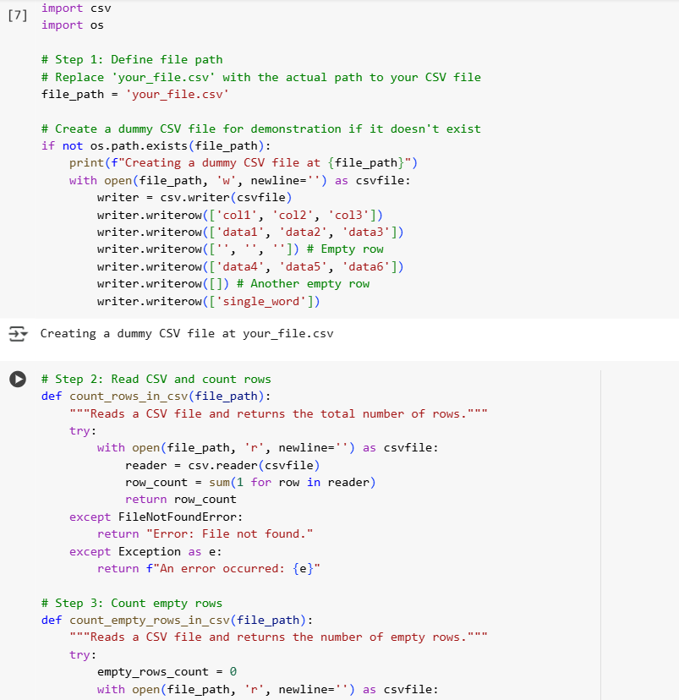

OUTPUT:

EXPLANATION:

TASK 5:

Example 1: Input: "Hello world! Hello AI." lowercase → hello world hello ai remove punctuation → hello world hello ai counts → hello=2, world=1, ai=1 Output: "hello" Example 2: Input: "Python, python, PYTHON is great!!!" lowercase → python python python is great remove punctuation → python python python is great counts → python=3, is=1, great=1 Output: "python" Example 3: Input: "Data science is fun; data is powerful." lowercase → data science is fun data is powerful remove punctuation → data science is fun data is powerful counts → data=2, science=1, is=2, fun=1, powerful=1 Output: "data" write a Python function The function must: • Accept a paragraph as input • Convert all text to lowercase • Remove punctuation • Return the most frequently use

OUTPUT:

EXPLANATION:

